**Business Context**

Our client is an insurance company that has provided Health Insurance to its customers now they need your help in building a model to predict whether the policyholders (customers) from past year will also be interested in Vehicle Insurance provided by the company. An insurance policy is an arrangement by which a company undertakes to provide a guarantee of compensation for specified loss, damage, illness, or death in return for the payment of a specified premium. A premium is a sum of money that the customer needs to pay regularly to an insurance company for this guarantee. For example, you may pay a premium of Rs. 5000 each year for a health insurance cover of Rs. 200,000/- so that if, God forbid, you fall ill and need to be hospitalized in that year, the insurance provider company will bear the cost of hospitalization etc. for up to Rs. 200,000. Now if you are wondering how company can bear such high hospitalizations cost when it charges a premium of only Rs. 5000/-, that is where the concept of probabilities comes in picture. For example, like you, there may be 100 customers who would be paying a premium of Rs. 5000 every year, but only a few of them (say 2-3) would get hospitalized that year and not everyone. This way everyone shares the risk with everyone else.

Just like medical insurance, there is vehicle insurance where every year customer needs to pay a premium of certain amount to insurance provider company so that in case of unfortunate accident by the vehicle, the insurance provider company will provide a compensation (called ‘sum assured’) to the customer.

Building a model to predict whether a customer would be interested in Vehicle Insurance is extremely helpful for the company because it can then accordingly plan its communication strategy to reach out to those customers and optimize its business model and revenue.

Now, to predict whether the customer would be interested in Vehicle insurance, you have information about demographics (gender, age, region code type), Vehicles (Vehicle Age, Damage), Policy (Premium, sourcing channel) etc.

**Gender – Previously Insured – Response -- Relationship**

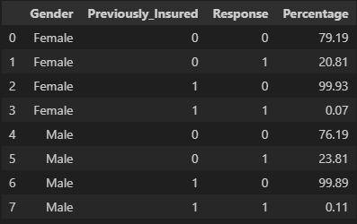

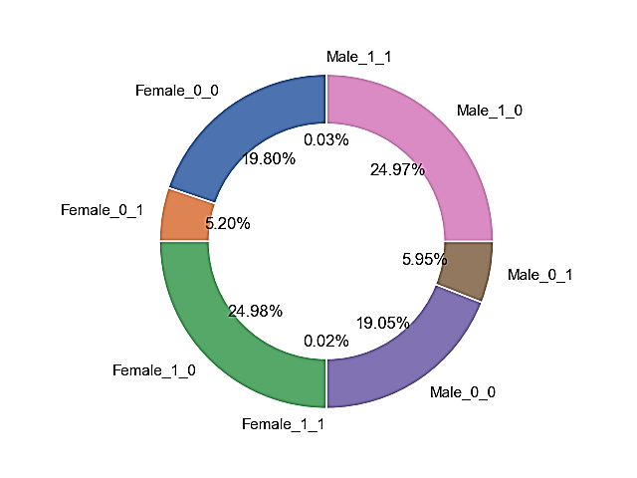

**Summary**

* Gender: Represents the gender of the individuals, with possible values being 'Female' or 'Male'.
* Previously Insured: Indicates whether the individuals were previously insured or not. It is a binary variable with values 0 (not previously insured) or 1 (previously insured).
* Response: Represents the response variable, possibly indicating whether the individuals responded positively (1) or negatively (0) to some event or condition.
* Percentage: Indicates the percentage of occurrences for each combination of 'Gender', 'Previously Insured', and 'Response'. It provides insights into the relative distribution of responses within each subgroup.

Here's a summary of a few rows from the data:

1. The first row indicates that approximately 79.19% of Females who were not previously insured and received a response of 0.
2. The second row shows that about 20.81% of Females who were not previously insured responded with a 1.
3. The third row indicates that almost 99.93% of Females who were previously insured responded with a 0.
4. The fourth row suggests that only 0.07% of Females who were previously insured responded with a 1.

**Gender – Vehicle Age – Damage - Response -- Relationship**

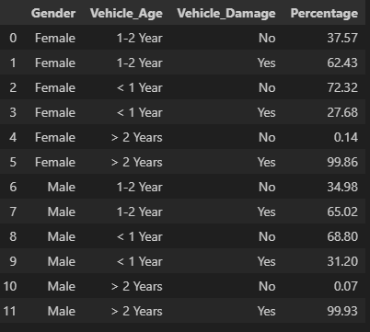

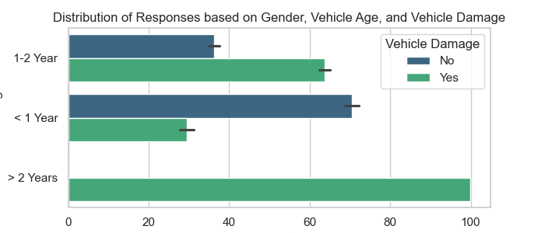

**Summary**

* Gender: This column specifies the gender of the individuals and has two possible values, 'Female' or 'Male'.
* Vehicle Age: Represents the age category of the vehicle, with three possible values - '1-2 Year', '< 1 Year', and '> 2 Years'.
* Vehicle Damage: This binary variable indicates whether the vehicle has been damaged or not. The value of 'Yes' suggests the vehicle is damaged, while 'No' indicates no damage.
* Percentage: Indicates the percentage of occurrences for each combination of 'Gender', 'Vehicle Age', and 'Vehicle Damage'. It provides insights into the relative distribution of responses within each subgroup.

Here's an example interpretation for the provided data:

1. In the second row, approximately 62.43% of Females with a vehicle age of '1-2 Year' and vehicle damage responded positively ('Yes').
2. In the fourth row, around 27.68% of Females with a vehicle age of '< 1 Year' and vehicle damage responded positively ('Yes').
3. In the sixth row, nearly 99.86% of Females with a vehicle age of '> 2 Years' and vehicle damage responded positively ('Yes').
4. In the eighth row, roughly 65.02% of Males with a vehicle age of '1-2 Year' and vehicle damage responded positively ('Yes').
5. In the eleventh row, almost 99.93% of Males with a vehicle age of '> 2 Years' and vehicle damage responded positively ('Yes').

These interpretations provide insights into how responses vary across different subgroups defined by gender, vehicle age, and vehicle damage status. Analyzing such data can help identify patterns and inform decision-making processes in various contexts, such as insurance or automotive industries.

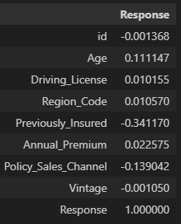

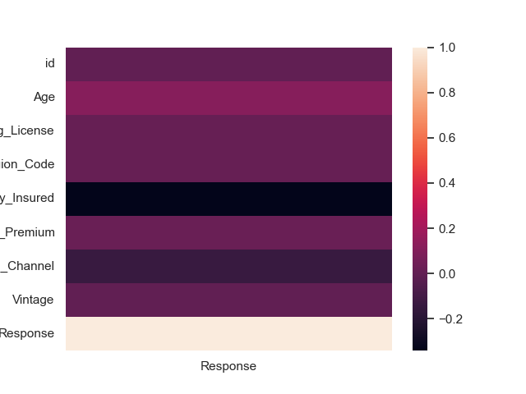

The table represent the correlation coefficients between the 'Response' variable and other features in a dataset. Correlation coefficients quantify the degree and direction of the linear relationship between two variables. Here's an explanation of the correlation coefficients in the

* Age: The correlation coefficient is approximately 0.1111. This indicates a weak positive correlation between 'Age' and 'Response'. As 'Age' increases, there is a slight tendency for 'Response' to increase as well.
* Driving License: The correlation coefficient is approximately 0.0102. This indicates a very weak positive correlation between 'Driving License' and 'Response'. However, the correlation is extremely small, suggesting a minimal linear relationship.
* Region Code: The correlation coefficient is approximately 0.0106. Similar to 'Driving License', there is a very weak positive correlation between 'Region Code' and 'Response'. The relationship is very subtle.
* Previously Insured: The correlation coefficient is approximately -0.3412. This suggests a moderate negative correlation between 'Previously Insured' and 'Response'. As the 'Previously Insured' status decreases (going from 1 to 0), there is a tendency for 'Response' to increase.
* Annual Premium: The correlation coefficient is approximately 0.0226. This indicates a very weak positive correlation between 'Annual Premium' and 'Response'. The relationship is minor, suggesting that higher annual premiums are only slightly associated with a higher likelihood of response.
* Policy_Sales_Channel: The correlation coefficient is approximately -0.1390. This suggests a weak negative correlation between 'Policy_Sales_Channel' and 'Response'. Changes in 'Policy_Sales_Channel' are associated with a slight decrease in 'Response'.
* Vintage: The correlation coefficient is approximately -0.0011. This indicates a very weak negative correlation between 'Vintage' and 'Response'. The linear relationship between these two variables is almost negligible.
* Response: The correlation coefficient is 1.0000, which is expected since the correlation of a variable with itself is always 1. This does not provide additional information about the relationship with other variables but indicates perfect correlation within the same variable.

Conclusion

In conclusion, the task at hand involves leveraging demographic, vehicle, and policy-related data to build a predictive model for determining customer interest in Vehicle Insurance. The company aims to optimize its communication strategy and enhance its revenue by identifying potential customers. The provided data offers insights into the distribution of responses across various subgroups, highlighting patterns within gender, vehicle age, and vehicle damage status. Additionally, correlation coefficients provide a quantitative understanding of the relationships between different features and the response variable. The moderate negative correlation with 'Previously Insured' suggests a notable impact on customer interest. While certain weak correlations exist with other features, their influence on the response variable is relatively minor. The comprehensive analysis of these factors equips the insurance company with valuable information to refine its approach and tailor its offerings to specific customer segments, ultimately contributing to a more effective business model.

The business can leverage the conclusions drawn from the analysis in several ways to gain a competitive advantage:

* Targeted Marketing Strategies: Tailor marketing campaigns based on identified patterns in demographics, vehicle details, and policy-related information. For instance, focus advertising efforts on segments that have shown a higher likelihood of positive responses.
* Personalized Communication: Utilize the insights from gender-based and vehicle-specific response distributions to personalize communication strategies. Craft messages that resonate with the preferences and characteristics of specific customer segments to enhance engagement.
* Risk Mitigation and Pricing Strategies: The moderate negative correlation between 'Previously Insured' and 'Response' suggests an opportunity to refine risk mitigation and pricing strategies. The business can adjust premium offerings or create incentives for individuals who were not previously insured, potentially attracting a larger customer base.
* Channel Optimization: Considering the weak negative correlation with 'Policy_Sales_Channel,' optimize the sales channels based on their impact on customer responses. Focus efforts on channels that exhibit a positive influence on customer interest, enhancing overall efficiency.
* Customer Segmentation: Further refine customer segmentation based on identified correlations. This can help the business create tailored insurance packages and offerings for specific customer groups, maximizing the likelihood of positive responses.
* Product Innovation: Use the analysis to identify gaps or opportunities for innovation in insurance products. Understand customer preferences and pain points to develop new offerings that align with market demands.
* Continuous Monitoring and Adaptation: Given the dynamic nature of the insurance industry, establish a system for continuous monitoring and adaptation. Regularly update the predictive model and refine strategies based on evolving customer behaviors and market trends.
* Customer Retention: Identify factors influencing customer satisfaction and loyalty, particularly related to vehicle insurance. Develop retention strategies to keep existing customers engaged and satisfied, thereby reducing churn.

By incorporating these insights into their business strategies, the insurance company can not only optimize its approach to attracting new customers but also enhance customer retention and satisfaction, leading to a more resilient and competitive business model.